Title (style: Heading 1)
Author1FirstName SecondName (style: Author and Name), name@where.and.where (style: Author and Name + Not Bold, Italic)
Dept of XYZ, University of XYX, City, Country, try to fit it all in 1 line (style: Address)
Author2FirstName SecondName (style: Author and Name), name@where.and.where (style: Author and Name + Not Bold, Italic)
Dept of XYZ, University of XYX, City, Country, try to fit it all in 1 line (style: Address)

Ignite Poster Abstract
Write the abstract in Normal style. Please format pictures with style: Figure. Add a caption for each picture, formatted with Figure caption style.
You can use figures and tables in the abstract that best represent your work. Your title, author information, abstract, and images should use up to a maximum of two pages. If you do not need a whole page, leave the remaining space blank.
The abstract should:
- Clearly identify the problem being addressed.
- Make relevant links to theory, policy, evidence, etc to support claims, aims, hypothesis, etc.
- Plainly stated objectives (of research or practice activity) with research questions (as appropriate).
- Provide a brief description of any learning activity design and implementation and/or technical solution demonstrating how it is aligned with constructionism and other relevant theories etc.
- Outline research context, data collection and analysis approaches.
- Present preliminary results.
- Identify potential implications of the study for practitioners/policy/research and our developing understanding of constructionism.

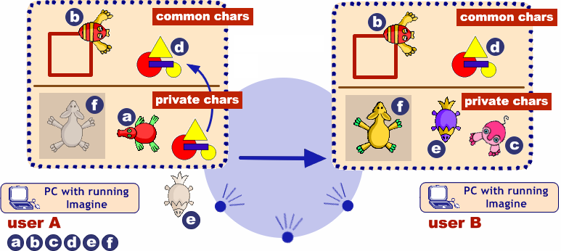
Figure 1. Sending and receiving common and private characters (style: Figure caption)
The quick brown fox jumps over the lazy dog. The quick brown fox jumps over the lazy dog. The quick brown fox jumps over the lazy dog. The quick brown fox jumps over the lazy dog. The quick brown fox jumps over the lazy dog. The quick brown fox jumps over the lazy dog. The quick brown fox jumps over the lazy dog. The quick brown fox jumps over the lazy dog. The quick brown fox jumps over the lazy dog. The quick brown fox jumps over the lazy dog. The quick brown fox jumps over the lazy dog.

References (Please use the APA citation style)
Salanci, L. (2001) Networking in Logo (style: Normal + Italic). In Proceedings of EuroLogo 2001. Edited by G. Futschek. Linz, August. pp. 67 − 74. (style: Normal)
Kalas, I. and Winczer, M. (2007) Building interfaces for on-line collaborative learning. Journal of Environmental Science, 84, 161−175.
Jones, A. B. and Smith, W. (1984) Statistical Methods for Scientists. Wiley, New York.
Galik, Z. (2007) Contributions to the theory of order statistics. Ph.D. thesis, Comenius University, Bratislava.

